ANA 610 Homework #4

Please refer to the assignment “grading rubric” for point allocation.
Please read the directions carefully.

Fortune Corp, a maker of specialized laboratory equipment for the pharmaceutical industry, began business in June 1980. Priding itself on employee job satisfaction, the company is seeking to understand why employees voluntarily leave the company.

Over the last 3 years, at the request of the SVP of Human Resources, the HR department has been conducting an employee survey. The SVP wants enough data collected so that a predictive model of employee voluntary attrition can be built and tested. The objective is to use such a model to find current employees who might be thinking of leaving, so proactive steps can be taken to retain them.

The SVP now thinks there has been enough data collected. So, she has requested that you, the lead data science team, take over and work your magic!

The qualifications for the target sample are having taken the survey. This sample is broken into two segments:

- Employees who voluntarily attritioned (left the company)
- Employees who are still with the company

Assume the analysis is taking place June 1, 2018.

The following 5 data files have been created for your use by the IT department:

- (csv) Credit Bureau file: fortune_credit.csv
  - FICO score (SVP thinks this might be predictive)
- (SAS) Accounting file: fortune_acct
  - Payroll data
- (SAS) Attrition file: fortune_attrition
  - Employees who have left the company over the 2015-2017 period
- (SAS) HR file fortune_hr
  - Background employee data
- (SAS) Survey file fortune_survey
  - Data collected from the employee survey

Unfortunately, there is no data dictionary for these data files. But most fields should be self-explanatory.

The data files are available online at SAS Studio.

Task #1 (100 pts): Generate a data audit report (using the audit report template) to be shared with both the HR and IT department; include a check of the available modeling sample size. Use SAS to generate the tables for the audit report and to assemble all 5 data files into a single, modeling data file which retains all available rows of data (i.e., do NOT subset based on the qualified sample).
Task #2 (22 pts):

Using R, redo the merging of the 5 “Fortune” datafiles.
- First, create and show here a Relational Datafile Structure for the 5 Fortune data files. See the Appendix to Week 1b Lecture slides for an example. Your structure should show: (i) the name of each datafile; (ii) each file’s linking variable name(s) and its (their) machine type; (iii) the number of rows in each datafile; and (iv) arrows which show how the datafiles are sequentially linked/merged with each other.
- Second, merge the datafiles and add a new column to the merged file called NEW_VARIABLE which has the value of “I did it again!” for all rows.
- Third, output the merged data file (an R data object) to an external file using save(). Label the file with your name and use a file extension of “.RData”.
- Fourth, show here R-generated output which shows:
  - The first 10 rows of the merged data file only for the two variables EMPLOYEE_NO and NEW_VARIABLE.
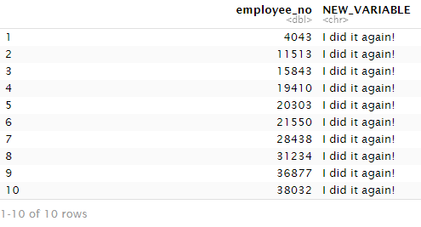
  - The number of rows in the data file.
See observations below.
  - The number of columns in the data file.
See variables below.

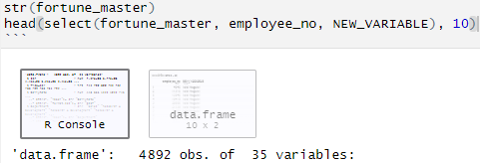

Task #3 (50 pts):

- After merging the 5 files, you should find duplicate rows. Deduplicate your SAS and R modeling data files:
  - Using SAS,
    - Show your SAS code here for how you would deduplicate.

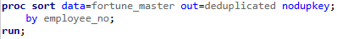

    - Show here SAS-generated output which shows the before and after row count.



  - Using R,
    - Show your R code here for how you would deduplicate.

    - Show here R-generated output which shows the before and after row count.

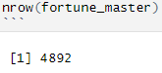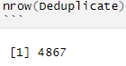

- Using your deduplicated data files, create two variables, one for AGE, employee age (in years), and one for TENURE, the length of time an employee has been with the company (in years). Create AGE and TENURE for all employees in the data file. HINT: how should TENURE be defined for those who left the company? What is the analysis date?
  - Using SAS,
    - Show your SAS code here for how you would create AGE and TENURE using the YRDIF() and FLOOR() functions.

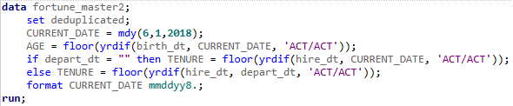
    - Show here SAS-generated output which reports the N, MEAN and MEDIAN for AGE and TENURE.

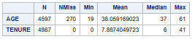

  - Using R,
    - Show your R code here for how you would create AGE and TENURE using the interval() and time_length() functions from the lubridate package and the floor() function.

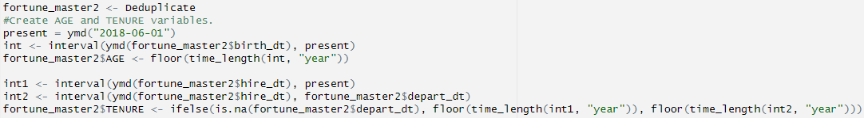

    - Show here R-generated output which reports the N, MEAN and MEDIAN for AGE and TENURE.

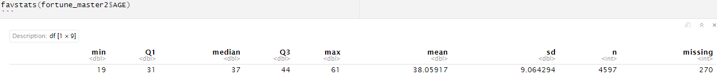

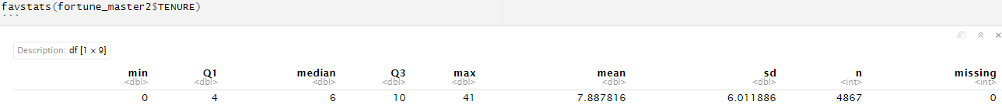

  - Using SAS or R, check AGE and TENURE for integrity issues. Specifically check for (a) missing values; (b) extreme values; and (c) extreme distribution. Fully discuss your findings. Show all relevant code-generated charts and tables.

For AGE:
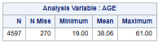

The 270 missing values for AGE variable are attributed to the 270 missing values for birth_dt in the merged file. Summary shows a mean AGE of 38 years.
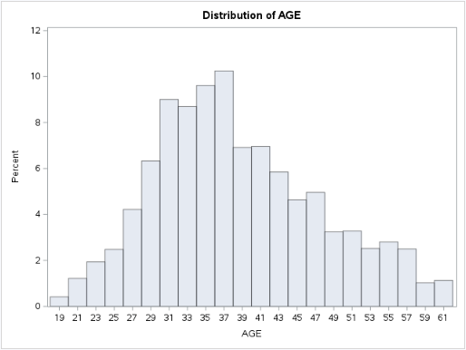

The distribution for the AGE variable appears to be reasonably normal, and also includes the current age of those who have departed from the company.

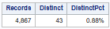

For TENURE:
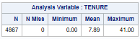
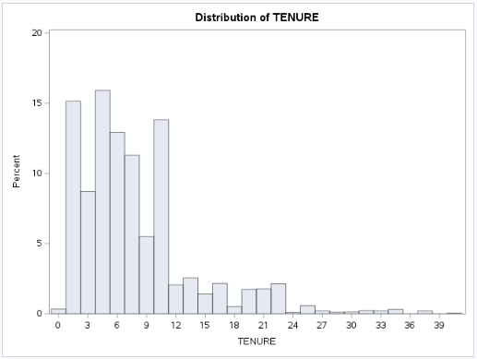
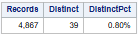

The summary shows a mean TENURE of close to 8 years. The distribution of the TENURE variable is considerably right skewed with most employees having 1-11 years of service to the company. This also includes the service time of those who have departed from the company.

- Using your deduplicated datafiles, create a target variable, ATT_Q, which takes on a value of 1 if an employee took the survey and voluntarily attritioned; or 0 if the employee took the survey and did not attrition.
  - Using SAS,
    - Show your SAS code here.

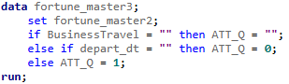

    - Show here SAS-generated output which shows how many employees (i.e., count or frequency) fall into each segment.

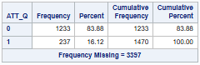

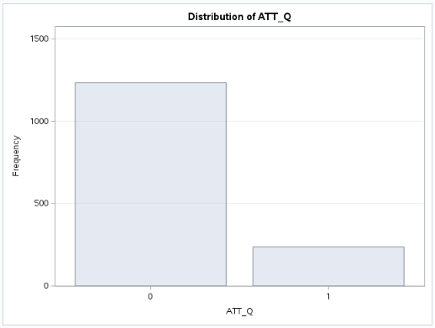

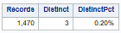

  - Using R,
    - Show your R code here.

    - Show here R-generated output which shows how many employees (i.e., count or frequency) fall into each segment.

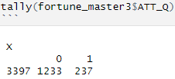

- You have found that AGE has missing values. Using SAS and your SAS deduplicated datafile, impute these missing values using Predictive Mean Matching (PMM). Use as control variables EDUCATION and HIRE_DT for this conditional imputation approach. Impute AGE across the entire datafile.
  - Fill in the following table with your findings:

Statistic | Observed Values | PMM  (Seed = 1234)
N | 4,597 | 4,867
Min | 19.000 | 19.000
Mean | 38.059 | 37.967
Median | 37.000 | 37.000
Max | 61.000 | 61.000
STD | 9.064 | 9.071
Correlation with EDUCATION | 0.225 | 0.231
Correlation with HIRE_DT | -0.282 | -0.287

  - Show the overlaid histogram (use BINWIDTH = 1) and boxplot produced by PROC SGPLOT.
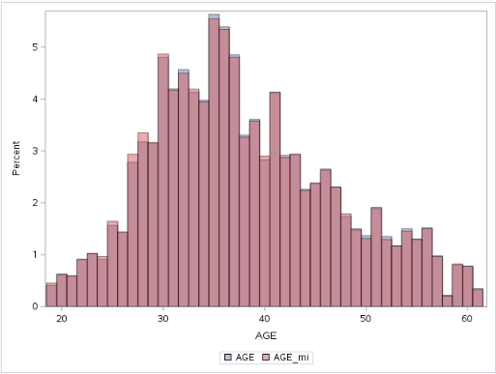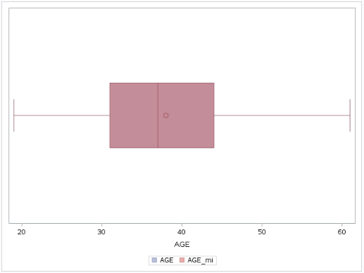
  - With reference to the statistics in the above table, briefly discuss how well the PMM imputation method performed.

Regarding the PMM imputation, there was a 5.9% increase in the number of sample values, a 0.24% decrease in the mean, and a 0.077% increase in the standard deviation. Both correlation results were within 0.01 of each other. The overlaid histogram and boxplot show that the imputation had a very marginal effect on the distribution. All indicators showed that the PMM imputation worked nicely.

Task #4 (38 pts):

Note: For Tasks #4 and #5, use the deduplicated SAS modeling datafile you created in Task #3 AND the imputed version of AGE.

Using PROC HPBIN and target-based enumeration,

- Fill in the following table template to analyze how many bins are appropriate for AGE and TENURE. Start with 10 bins. Then, using a threshold of 20 for each segment of the target variable, determine how many bins should be created (HINT: 10 is too many). If there are missing values, ignore the bin that captures these in your final bin count.

Use a separate table for each variable.

For AGE regarding target variable ATT_Q:

Binning Type |  | Number of Bins | Number of Bins which Pass Threshold | Variable-level Information Value (IV)
Equal Height | Starting bin count | 10 | 4 | 0.307
 | Final bin count | 5 | 5 | 0.258
Equal Width | Starting bin count | 10 | 6 | 0.297
 | Final bin count | 4 | 4 | 0.185

For TENURE regarding target variable ATT_Q:

Binning Type |  | Number of Bins | Number of Bins which Pass Threshold | Variable-level Information Value (IV)
Equal Height | Starting bin count | 10 | 6 | 0.846
 | Final bin count | 4 | 4 | 0.497
Equal Width | Starting bin count | 10 | 3 | 0.448
 | Final bin count | 2 | 2 | 0.025

- For each variable AGE and TENURE, support your final bin count by showing the relevant PROC HPBIN output which displays the counts by bin/segment. (Note: there should be 4 sets of output.)

Equal Height for AGE regarding ATT_Q with 5 bins:

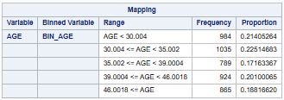
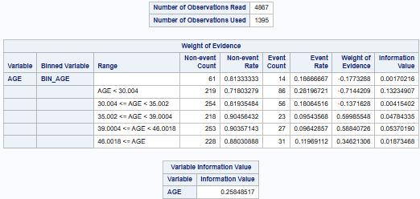

Equal Width for AGE regarding ATT_Q with 4 bins:

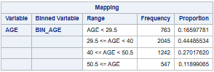
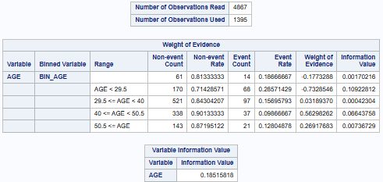
Equal Height for TENURE regarding ATT_Q with 4 bins:

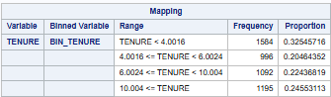
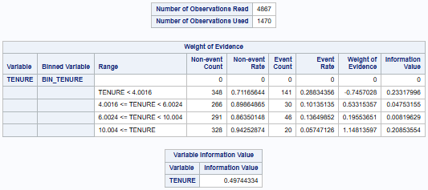

Equal Width for TENURE regarding ATT_Q with 2 bins:

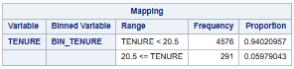
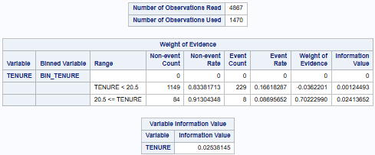

- For each variable AGE and TENURE, explain, if you had to pick one type of binning, which binning type (equal height or equal width) should be selected for your predictive model of attrition. Focus on the variable-level IV to support your selection.

Both AGE and TENURE, held at the minimum 20 event count for non-events and events with ATT_Q target variable, showed stronger IV values and more bins with equal height binning than equal width binning (AGE: 0.258 > 0.185, 5 > 4; TENURE: 0.497 > 0.025, 4 > 2). The equal width binning method for TENURE could not meet the required 20 event threshold, due to a large allocation of attrition events associated with shorter tenures. The equal height binning method would be chosen here. Please note that there is somewhat of a positive correlation between bin reduction and the variable information value. Thresholds need to be carefully chosen not to undermine the potential effect of an explanatory variable (i.e. TENURE) on the target variable (i.e. ATT_Q). Could see the rationale for testing dummy variables, each with a varying number of bins employed, in the prospective predictive model. In addition, see performing a binning method on a transformed explanatory variable as an option as well.

- For each variable AGE and TENURE,
  - Create dummy variables for each bin for your selected binning type. The dummy variable names should show the relevant bin ranges. Show your code here.

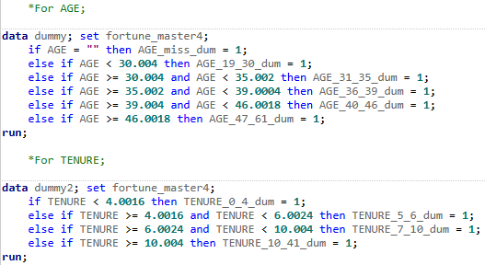

  - Using PROC MEANS and PROC TRANSPOSE, produce and show here a “tall and skinny” output table for each set of bin dummy variables which shows the bin dummy variables as rows with the sum for each bin by target variable segment as columns (so, N rows by 3 columns).

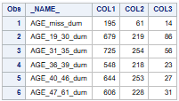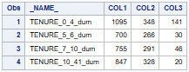
  - Check that for each bin/segment of your bin dummy variables, the threshold is met and that the sum for each bin matches the output from your final PROC HPBIN run. Show relevant, side-by-side SAS output which supports your analysis here.

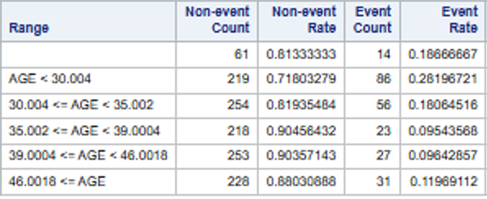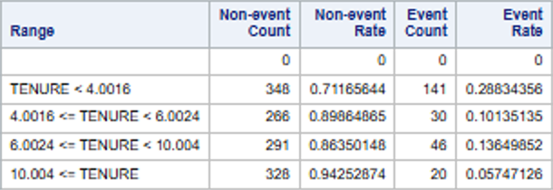

Segments of output from Task#4 Question 2 have been taken and placed above to compare to the code and tables shown in Task#4 Question 4a & b on the previous page. The column values align and match for the created dummy binning variables non-event (COL2) and event (COL3) totals for the attrition (ATT_Q) variable. The dummy binning variables were also assigned to those who did not take the survey represented in COL1.

Task #5 (10 pts):

Using PROC CORR and the bin dummy variables you created above for AGE and TENURE:

- Identify which employee AGE range is most likely to attrition. Support your answer by showing output from PROC CORR here.

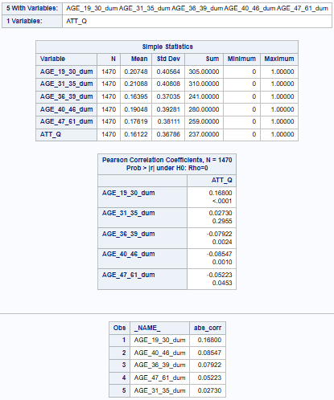

The 19 to 30 year age group is the most likely to attrition. The dummy variable AGE_19_30_dum has the highest correlation (0.168) and the lowest p-value (<.0001) of the five age groups, meaning it has the strongest statistical relationship with the target variable ATT_Q.
- Identify which employee TENURE range is most likely to attrition. Support your answer by showing output from PROC CORR here.

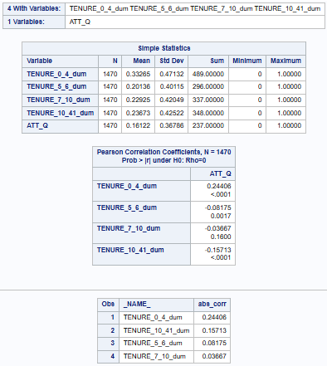

The 0 to 4 year tenure group is the most likely to attrition. The dummy variable TENURE_0_4_dum has the highest correlation (0.244) of the five age groups, and an extremely low p-value (<.0001), meaning it has the strongest statistical relationship with the target variable ATT_Q.

Extra Credit (35 pts)

- In the full, deduplicated, imputed datafile there are 6 obvious extreme values in the variable hire_dt. Why are they “obvious”? Explain fully your logic and provide a table showing employee_number, hire_dt and TENURE for these 6 “outliers.”

The company began in June 1980, but there are 6 extreme values for hire date that predate it.

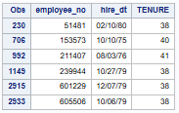

- Now use the course clustering method (i.e., the one that uses pmin) to try to identify these extreme values in the full, deduplicated, imputed datafile. Show the relevant SAS output.

  - What does pmin need to be set at to capture these 6 employees? Explain fully. Include any relevant SAS output and counts of employees in your answer.

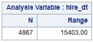

15,403 days / 4,867 employees = 3.165 days per employee
3.165 days per employee / 15,403 days = 0.02055% = starting pmin

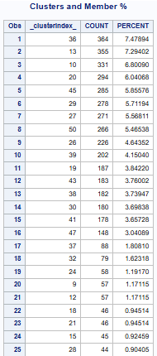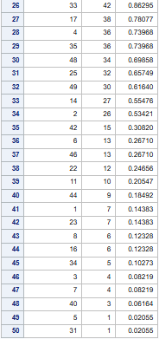

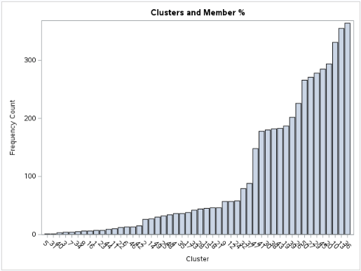
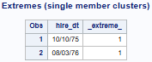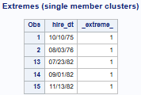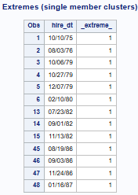
pmin= 0.02055% pmin= 0.06164% pmin= 0.08219%

The optimal pmin of 0.02055% that was calculated above yielded only two single member clusters, but two that needed to be eliminated. Looking at the generated table on the previous page, I proceeded with the pmin of 0.06164% that yielded five single member clusters, but still only included two that needed elimination. Referring to the table again, I proceeded with the pmin of 0.08219% that yielded thirteen single member clusters, and finally contained the six that needed to be eliminated.

  - What can you conclude with respect to a benchmarking approach vs an automated approach for identifying extreme values? Explain fully.

In this circumstance, the benchmarking approach was the most appropriate method, given that the cutoff date of June 1, 1980, was known. The clustering method recognizes proximity of values to each other, and that recognition can potentially supersede any ordering or sequence of the data. This mostly automated approach, with the exception of pmin determination, can fall short in certain applications. Since we were aware of the location of the outliers, we probably could have used other mostly automated approaches (i.e. Bottom 1% or 3 Standard Deviations), with the exception of some parameter adjustments.

- Using the full, deduplicated, imputed datafile which contains all variables (35+), including the AGE and TENURE dummy variables created in Task #3, check for variable redundancy using PROC VARCLUS. Considerations:

- Restrict your analysis to only “TYPE = 1” variables (machine numeric).
- Exclude ATT_Q, EMPLOYEE_NO, BIRTH_DT, AGE (observed), and DEPART_DT from consideration.
- Set MAXEIGEN = 0.7.
- Restrict your sample to where ATT_Q = 1 or 0 (i.e., the qualified sample)

  - Show the PROC MEANS output for the variables which will be checked for redundancy.

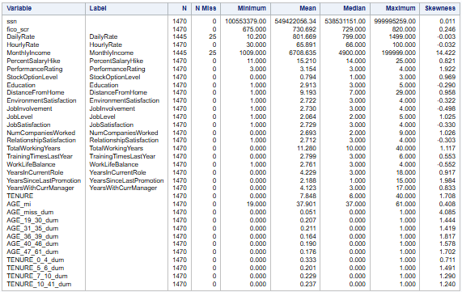

  - Show the output reporting the cluster membership (i.e., which variables are assigned to which clusters).

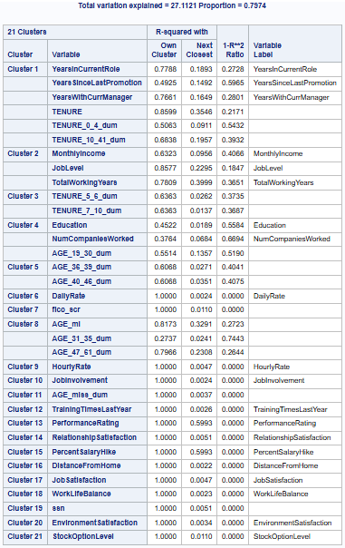
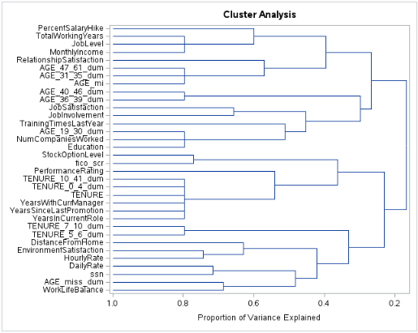

  - For each multivariable cluster, indicate which variable should be used as the representative variable.

*Concerning Cluster #1, TENURE possesses the highest r-squared value in the cluster, and
has an obvious relationship with other variables in the cluster.

*Concerning Cluster #2, JobLevel possesses the highest r-squared value in the cluster, and it is hard to deny a relationship to MonthlyIncome and TotalWorkingYears. I would like to test a transformed version of MonthlyIncome as well.

*Concerning Cluster #3, TENURE_5_6_dum and TENURE_7_10_dum could be interchangeable. Since TENURE is already being accounted for in Cluster #1, I would consider completely eliminating this cluster, or could see the transformed version of MonthlyIncome potentially filling this spot.

*Concerning Cluster #4, AGE_19_30_dum possesses the highest r-squared value in the cluster, but unsure of its relationship to Education and NumCompaniesWorked. Given that AGE_mi will likely be included in Cluster #8, I would consider choosing Education here.

*Concerning Cluster #5, AGE_36_39_dum and AGE_47_61_dum could be interchangeable. Given that AGE_mi will likely be included in Cluster #8, I would consider completely eliminating this cluster. Possibly adding NumCompaniesWorked here, given our target variable relates to attrition.

*Concerning Cluster #8, AGE_mi possesses the highest r-squared value in the cluster, and it has an obvious relationship with the other dummy variables in the cluster. Think AGE_mi may be a candidate for transformation as well.

Note: Cluster #11, AGE_miss_dum, and Cluster #19, ssn, could be removed as well.

  - Explain how effective PROC VARCLUS is in reducing redundant variables in this datafile. Include in your explanation the % of variation explained by the cluster solution and how many variables have been eliminated.

Not withstanding my judgement calls, I was completely impressed with how PROC VARCLUS works, and how it generated this information fairly quickly in SAS studio. Explaining 27.1121% of the variation while settling on 21 clusters was good. After reviewing the information in 3c, I could potentially see a reduction to 18 variables from 34 included in the analysis, about a 47% reduction in numeric variables potentially used for modeling. After settling on what variables to retain, I think it might be worthwhile to run this again to see what comes from it.

Thinking that learning this method is better than icing on the cake in completing this course. It is more like the cherry on the top. Thank you, Kevin, and hope to reconvene in ANA625. On to data mining with Python in January, but I have already purchased a corresponding book for R as well. Developing quite a library from these courses. I greatly appreciate your work, and meant what I said about it. Enjoy your holiday break.

Homework deliverables:

Task #1
- Neatly formatted, data audit report (see template) – Word doc.
- Merged csv datafile (download from SAS Studio).

Task #2
- Merged R datafile, output using the save() function.
- R program with all code used to merge the 5 attrition data files and output the resulting merged file.

Tasks #2-5
- An additional Word doc with your analysis and discussion, including all tables and charts and code where requested.
- A SAS program with all code used for this assignment (Tasks 1 - 5).

